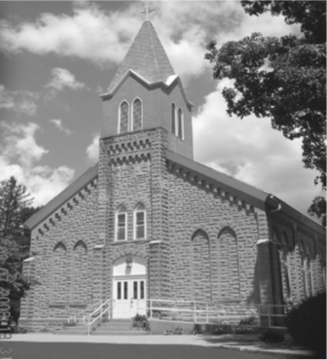
Saint Mary’s Village Church
P.O. Box 155
St. Mary-of-the-Woods, IN 47876
812-535-1261
jiannaccone!840@gmail.com
July 4, 2021
Fourteenth Sunday in Ordinary Time

Our Mission: St. Mary’s Village Church is a Roman Catholic Community united through our common bonds of worship, faith formation, community building, outreach to others and responsible stewardship of resources. Together, we work to build up the Body of Christ by giving witness to the gospel message of Jesus.

Parish Life Coordinator Sr. Jane Iannaccone, SP 781-622-0440
Sacramental Minister Fr. Darvin Winters
Coordinator of Religious Education Jamie Richey

Sacramental Life
Weekend Worship Sunday 9:00 a.m. Reconciliation 1st Sunday – 8:30 a.m.

The sacraments of Baptism and Matrimony are arranged by calling the Parish Office to schedule preparation.

We welcome new members. To enroll call the Parish Office.

Today’s Readings: Ezekiel 2:2-5, 2Corinthians 12:7-10, Mark 6:1-6
Responsorial Psalm: our eyes are fixed on the Lord, pleading for his mercy.

Lectors: 7/4 Marilen Wegner, 7/11 Carol Cummins, 7/18 Caleb Fleschner, 7/25 Chris Mangia

Mass Intentions
For: By:
July 4 Bennie Bird Jamie & Keith Richey
July 11 Stephen Kraus Sister Jane Iannaccone

if you wish to have a mass said, the suggested stipend is $10.00. We are now scheduling masses for the second half of 2021

Please pray for:
Louise Arnold, Bill Marrs, Dick Stultz, Ronald Heyen, Janice Arnold, Jeannette Wrin, John Kirkham, Laura Stane, John & Joanne Kahl, Jonnie Hooper
Finance Report
June27, 2021 | Budgeted | Actual |  | Additional Donations
Sunday Collection | $2096 | $4560 |  | Anonymous Donation | $1000.00
Galvin Fund Donations | $96 | $
Cemetery | $334 | $

Birthday Blessings 7/4 Ben Bird, Joslyn Wrin, 7/7 Karen Harris, Jaclyn Ramsey 7/10 Barbara Rohrbach

Looking for activities for the kids this summer? Join us for Summer with the Saints, we will be meeting out-doors on Wednesday July 7th from 3:30-4:00 to hear a saint story and do a fun craft. All ages are welcome. Contact Jamie with any questions 812-208-6157

Mark your calendars Vacation Bible School will be held July 19th-23rd 6:00-8:30pm. Ages Pre-school to entering 5th grade. This year VBS will be held out -doors. If you would like to volunteer to help or register your child, please contact Jamie Richey

Please join today after mass in Galvin Hall for coffee & donuts. As a special thank you for all your prayers and loving support the Wrin family has donated the coffee and donuts. Please join us in thanks.

Independence Day Prayer
God, source of all freedom, this day is bright with memory of those who declared that life and liberty are your gift to every human being. Help us to continue a good work begun long ago.

Make our vision clear and our will strong, that only in human solidarity will we find liberty, and justice only in the honor that belongs to every life on earth.

Turn our hearts toward the family of nations; to understand the ways of others, to offer friendship, and to find safety only in the common good of all. We ask this through Christ our Lord. Amen.

There will be a Hunger Bust Committee meeting on July 11th immediately after mass in Galvin Hall.

