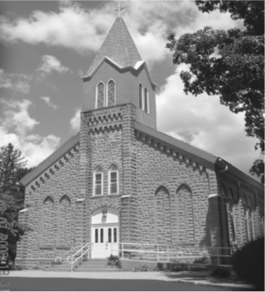
Saint Mary’s Village Church
P.O. Box 155
St. Mary-of-the-Woods, IN 47876
812-535-1261
Jiannaccone!840@gmail.com
March 14, 2021
Third Sunday of Lent

Our Mission: St. Mary’s Village Church is a Roman Catholic Community united through our common bonds of worship, faith formation, community building, outreach to others and responsible stewardship of resources. Together, we work to build up the Body of Christ by giving witness to the gospel message of Jesus.

Parish Life Coordinator Sr. Jane Iannaccone, SP 781-622-0440
Sacramental Minister Fr. Darvin Winters
Coordinator of Religious Education Jamie Richey

Sacramental Life
Weekend Worship Sunday 9:00 a.m. Reconciliation 1st Sunday – 8:30 a.m.

The sacraments of Baptism and Matrimony are arranged by calling the Parish Office to schedule preparation.

We welcome new members. To enroll call the Parish Office.

Today’s Readings 2chr 36:14-16, 19-23, Eph2:4-10, John 3:14-21
Responsorial Psalm: let my tongue be silenced if I ever forget you.

Mass Intentions
For: By:
March 14 John Marrs Pete Secondino & Jody Crandell
March 21 John Marrs Pete Secondino & Jody Crandell

if you wish to have a mass said, the suggested stipend is $10.00. We are now scheduling masses for the second half of 2021

Please pray for:
Louise Arnold, Ruth Thralls, Bill Marrs, Dick Stultz, Ronald Heyen, Tony Dubois, Janice Arnold, Jeannette Wrin, John Kirkham

The first Sunday of each month we will be praying the rosary together before Mass intention will be for an end of COVID and a return to Mass as a parish family.

The Solemnity of St Joseph is on Friday March 19th abstaining from meat is not required on a solemnity including during Lent, therefore Catholics are not obligated to abstain from meat on, Friday March 19th

Finance Report
March 7, 2021 | Budgeted | Actual |  | Additional Donations
Sunday Collections | $2096 | $2717
Galvin Fund Donations | $96 | $276
Cemetery | $334

Birthday Blessings: 3/14 Roy Lucas, 3/15 Sally Rice, 3/16 Casey Sereno, 3/17, Analiza Brockmeier, Erica Stranahan 3/19 Caleb Fleschner Anniversary 3/16 Mark & Debbie Dailey

Who needs a date night??? The Faith Formation Committee will be raffling a date night basket on March 17th with proceedings benefiting the Providence Food Pantry. Today is the last Sunday to purchase tickets after Mass. The drawing will take place live on the religious ed. Facebook page at 7:00pm. See Jamie Richey, Kim La Comba, Kelly Stafford, Chris Mangia or Emma Kelley to get your ticket

The parish has a subscription to Formed think of it as a Catholic Netflix. There are movies, audio books. Cartoons, bible studied etc. To access it go to formed.org/signup enter the parish zip code 47876. You can watch shows on your Smart TV, phone, or computer. Enjoy!

The Stations of the Cross will take place every Friday during Lent at 3:00pm in the church.

The Resurrection Easter Egg Hunt will be held on Palm Sunday March 28th. All children are invited to attend the egg hunt after Mass. A basket will be placed in the back of the church for candy donations. Thank you in advance for your support
COVID update: The bishops of Indiana have extended the dispensation from mass attendance until further notice. In keeping with the governor’s mandates, we will be requiring all who attend mass from now on to wear face covering such as a mask, scarf or face shield. While this is uncomfortable, it is necessary to protect ourselves and our neighbors. Masks are available at the church entrance

