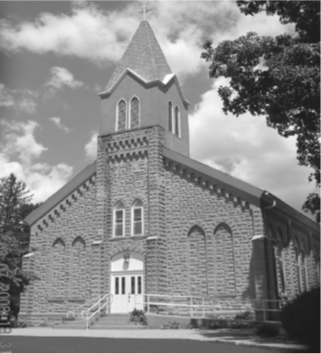
Saint Mary’s Village Church
P.O. Box 155
St. Mary-of-the-Woods, IN 47876
812-535-1261
jiannaccone!840@gmail.com
July 18, 2021
Sixteenth Sunday in Ordinary Time

Our Mission: St. Mary’s Village Church is a Roman Catholic Community united through our common bonds of worship, faith formation, community building, outreach to others and responsible stewardship of resources. Together, we work to build up the Body of Christ by giving witness to the gospel message of Jesus.

Parish Life Coordinator Sr. Jane Iannaccone, SP 781-622-0440
Sacramental Minister Fr. Darvin Winters
Coordinator of Religious Education Jamie Richey

Sacramental Life
Weekend Worship Sunday 9:00 a.m. Reconciliation 1st Sunday – 8:30 a.m.

The sacraments of Baptism and Matrimony are arranged by calling the Parish Office to schedule preparation.

We welcome new members. To enroll call the Parish Office.

Today’s Readings: Jeremiah23:1-6, Ephesians2:13-18, Mark6:30-34
Responsorial Psalm: The Lord is my shepherd; there is nothing I shall want.

Lectors: 7/18 Caleb Fleschner, 7/25 Chris Mangia, 8/1 Patty Curley, 8/8 Steve Norris

Mass Intentions
For: By:
July 18 Gladys Langowski Marelin Wegner
July 25 Jerry Hooper Jeannette & John Wrin

if you wish to have a mass said, the suggested stipend is $10.00. We are now scheduling masses for the second half of 2021

Please pray for: Louise Arnold, Bill Marrs, Dick Stultz, Ronald Heyen, Janice Arnold, Joe Mangia Jeannette Wrin, John Kirkham, Laura Stane, John & Joanne Kahl, Jonnie Hooper, Flo Callahan, Elizabeth Pope
A note from Sister Jane
Today’s Responsorial Psalm is taken from the 23rd Psalm also known as the Good Shepard psalm. This psalm is probably one of the most popular psalms in Christian homes, When I was in the fourth grade, prayer was still allowed in the public schools. One of my fondest memories is that my fourth, grade teacher would begin the day by having us read the 23rd Psalm. By the end of the school year, we had it memorized! It was my first introduction to the psalms. I love the psalms because no matter what you may be feeling you can find a psalm that fits that emotion.

Father Darvin will be away until August 18th. With gratitude I welcome Fr. Dan Hopcus who will be filling in as our sacramental minister for these four weeks. Fr. Dan just recently retired as full-time chaplain for the Sisters of Providence community. I haven’t give him much time to enjoy his retirement before asking him to fill in for us

Finance Report
July 11, 2021 | Budgeted | Actual |  | Additional Donations
Sunday Collection | $2096 | $1561
Galvin Fund Donations | $96 | $26
Cemetery | $334 | $100

Birthday Blessings: 7/20 Robert Easton,7/22 Sarah Holbert 7/24 Jacob Holbert Anniversary Blessings: 7/23 Jack & Mary Whallon

Summer with the Saints, is canceled for this week because of VBS. See you next week.

Vacation Bible School will be held July 19th-23rd 6:00-8:30pm. Ages Pre-school to entering 5th grade. This year VBS will be held out -doors. If you would like to volunteer to help or register your child, please contact Jamie Richey

The Kick-off for the 9th annual HUNGER BUST fun run/walk is today, July 18th. You can register today after Mass. Over $40,000 has been donated to the Providence Food Pantry through this event. Be sure to mark your calendar SEPTEMBER 11th and be part of HUNGER BUST 2021!

