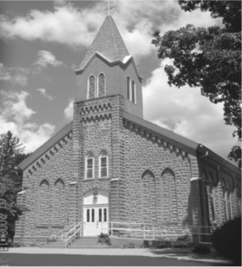

Saint Mary’s Village Church
P.O. Box 155
St. Mary-of-the-Woods, IN 47876
812-535-1261
www.stmarysvillagechurch.org
November 15, 2020
Thirty-Third Sunday in Ordinary Time

Our Mission: St. Mary’s Village Church is a Roman Catholic Community united through our common bonds of worship, faith formation, community building, outreach to others and responsible stewardship of resources. Together, we work to build up the Body of Christ by giving witness to the gospel message of Jesus.

Parish Life Coordinator Sr. Jane Iannaccone, SP 781-622-0440
Sacramental Minister Fr. Darvin Winters
Coordinator of Religious Education Jamie Richey

Sacramental Life

Weekend Worship Sunday 9:00 a.m. Reconciliation 1st Sunday – 8:30 a.m.

The sacraments of Baptism and Matrimony are arranged by calling the Parish Office to schedule preparation.

We welcome new members. To enroll call the Parish Office.

Today’s Readings: Wis Pr31:10-13,19-20, 30,31 Ps.128, 1Thes 5:1-6, Mt 25:14-30or 25:14-15,19-21
Responsorial Psalm: Blessed are those who fear the Lord

A Note from Sister Jane: My vow ring is inscribed with the words “All is gift from a loving God.” It is a constant reminder to me that all I have is a gift from God. God has given us different gifts and talents. In todays gospel we are encouraged to use these God given gifts to build up the kingdom of God. What act of kindness can you do this week to build up the kingdom of God?

Mass Intentions
For: By:
Nov. 15 Carolyn Marrs Louise Arnold
Nov. 22 Tom Rogier JOE &Chris Mangia
If you wish to have a mass said, the suggested stipend is $10.00. We are now scheduling masses for the first half of 2021.

Please pray for:
Louise Arnold, Ruth Thralls, Bill Marrs, Dick Stultz, Dan Kane, Ronald Hey, Tony Dubois If you have specific people you would like to have on the parish prayer list, please contact Sister Jane

Next weekend a basket will be provided for the national collection for the Catholic Campaign for Human Development (CCHD) your support for this collection empowers those Living in poverty to transform their lives. 50% of this collection stay right here to be used in this archdiocese

Finance Report

Oct 25, 2020 | Budgeted | Actual |  | Additional Donations
Sunday Collections | $2096 | 1,192.00 | World Missions | 25.00
Galvin Fund Donations | $96 | S60.00
Cemetery | $334

There will be an interfaith Thanksgiving Pray Service on November 23rd at 7:00pm at The Bethany United Church of Christ @01 West Miller St. West Terre Haute IN. 47885, all are welcome to attend.

Religious Education News

Throughout the month of November, we will be collecting mittens and gloves for the Providence Food Pantry. You may place your donated mittens and gloves on the Mitten Tree in the church. Last year we collected 300 mittens, do you think we can do it again ?!?!

Join us in Galvin hall on Thursday evenings at 6:30 to view and discuss the Chosen. There are eight sessions each about one hour long beginning September 17th
If you have any questions or concerns about any Faith formation programs, please contact Jamie 812-208-6157 or jrichey75@gmail.com

COVID UPDATE: The bishops of Indiana have extended the dispensation from mass attendance until further notice. In keeping with the governor’s upcoming mandates, we will be requiring all who attend mass from now on to wear face covering such as a mask, scarf or face shield. While this is uncomfortable, it is necessary to protect ourselves and our neighbors. Masks are available at the church entrance. Children under the age of 8 are exempt from this. Thank you for understanding and Those who have difficulty wearing face coverings, are encouraged to continue to view mass on the TV or internet.

