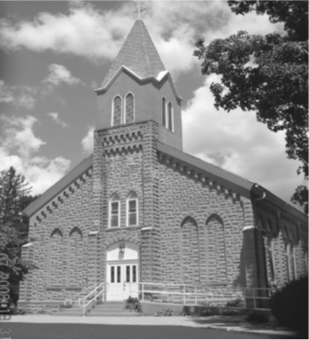
Saint Mary’s Village Church
P.O. Box 155
St. Mary-of-the-Woods, IN 47876
812-535-1261
jiannaccone!840@gmail.com
June 6, 2021
The Most Holy Body & Blood of Christ

Our Mission: St. Mary’s Village Church is a Roman Catholic Community united through our common bonds of worship, faith formation, community building, outreach to others and responsible stewardship of resources. Together, we work to build up the Body of Christ by giving witness to the gospel message of Jesus.

Parish Life Coordinator Sr. Jane Iannaccone, SP 781-622-0440
Sacramental Minister Fr. Darvin Winters
Coordinator of Religious Education Jamie Richey

Sacramental Life
Weekend Worship Sunday 9:00 a.m. Reconciliation 1st Sunday – 8:30 a.m.

The sacraments of Baptism and Matrimony are arranged by calling the Parish Office to schedule preparation.

We welcome new members. To enroll call the Parish Office.

Today’s Readings: Exodus 24:3-8, Hebrews 9:11-15, Mark 14 12-16,22-26
Responsorial Psalm: I will take the cup of salvation, and call on the name of the Lord

Lectors: 6/6 Patty Curley, 6/13 Steve Norris, 6/20 Dave Hudgens 6/27 Eddie Breneman

Mass Intentions
For: By:
June 6 Irene Mangia Joe & Chris Mangia
June 13 Hazel McKinney Jim & Flo Callahan

if you wish to have a mass said, the suggested stipend is $10.00. We are now scheduling masses for the second half of 2021

Please pray for:
Louise Arnold, Bill Marrs, Dick Stultz, Ronald Heyen, Janice Arnold, Jeannette Wrin, John Kirkham, Laura Stane, John & Joanne Kahl, Jonnie Hooper, Jane Frazier

Finance Report
May 30, 2021 | Budgeted | Actual |  | Additional Donations
Sunday Collections | $2096 | 1867.00
Galvin Fund Donations | $96
Cemetery | $334

Birthday Blessings 6/6 Seth Rohrbach, Sarah Wyrick 6/8 Joe Mangia, Christy Taylor, Troy Ramsey 6/10 Theresa Klotz
Anniversary Blessings: 6/6 Chris& Joe Mangia, 6/11 Jeannette & Richard Stultz

Beginning Sunday, June 6th we will be returning to the practice of having donut Sunday on the first Sunday of the month. Thank you to the book study group who is hosting and Chris & Joe Mangia for donating the donuts in celebration of their 51st Anniversary

Looking for activities for the kids this summer? Join us for Summer with the Saints, we will be meeting out-doors each Wednesday beginning June 9th from 3:30-4:00 to hear a saint story and do a fun craft. All ages are welcome. Contact Jamie with any questions 812-208-6157

Mark your calendars Vacation Bible School will be held July 19th-23rd 6:00-8:30pm. If you would like to volunteer, please contact Jamie

If you know anyone who would be interested in learning more about the Catholic faith and becoming a member of the Catholic church, please have them contact Sister Jane

There will be a Faith Formation Meeting on Wednesday June 9th at 6:00pm in Galvin Hall.

Archbishop Thompson and the other bishops of the State of Indiana are lifting the general dispensation from the obligation to attend Mass in person on Sundays and Holy Days effective on June 11, the Solemnity of the Most Sacred Heart of Jesus

