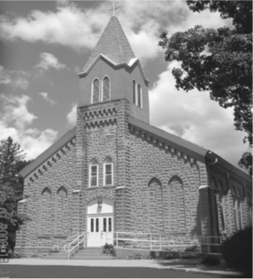
Saint Mary’s Village Church
P.O. Box 155
St. Mary-of-the-Woods, IN 47876
812-535-1261
jiannaccone!840@gmail.com
August 1, 2021
Eighteenth Sunday in Ordinary Time

Our Mission: St. Mary’s Village Church is a Roman Catholic Community united through our common bonds of worship, faith formation, community building, outreach to others and responsible stewardship of resources. Together, we work to build up the Body of Christ by giving witness to the gospel message of Jesus.

Parish Life Coordinator Sr. Jane Iannaccone, SP 781-622-0440
Sacramental Minister Fr. Darvin Winters
Coordinator of Religious Education Jamie Richey

Sacramental Life
Weekend Worship Sunday 9:00 a.m. Reconciliation 1st Sunday – 8:30 a.m.

The sacraments of Baptism and Matrimony are arranged by calling the Parish Office to schedule preparation.

We welcome new members. To enroll call the Parish Office.

Today’s Readings: Exodus16:2-4,12-15, Ephesians 17,20-24, John 6:24-35
Responsorial Psalm: The Lord gave them bread from heaven.

Lectors: 8/1 Patty Curley, 8/8 Steve Norris, 8/15 David Hudgens

Mass Intentions
For: By:
August 1 Jerry Hooper Jim & Flo Callahan
August 8 Mary Ruth Thralls Carol & Charlie Cummins
if you wish to have a mass said, the suggested stipend is $10.00. We are now scheduling masses for the second half of 2021

Please pray for: Louise Arnold, Bill Marrs, Dick Stultz, Ronald Heyen, Janice Arnold, Joe Mangia Jeannette Wrin, John Kirkham, Laura Stane, John & Joanne Kahl, Jonnie Hooper, Flo Callahan, Elizabeth Pope

Please remember in your prayers Mary Boyll whose Mass of Christian burial was celebrated here this past Thursday. May her soul and all the souls of the faithfully departed rest in peace

A note from Sister Jane
I have received some questions about us continuing to wear masks at our Sunday liturgy. My reason for continuing this practice is because of the increase of COVID cases in Vigo County and the small size of our church that does not allow for us to be socially distant. I feel that this is a small sacrifice that we can all make for the safety of the vulnerable members of our parish community.

Unfortunately, we will not be having donut Sunday today as Square Donuts is on vacation. We will have donut Sunday next Sunday August 8th instead.

July 25, 2021 | Budgeted | Actual |  | Additional Donations
Sunday Collection | $2096 | $1686
Galvin Fund Donations | $96 | $25
Cemetery | $334 | $

Father Darvin will be away until August 15th. With gratitude I welcome Fr. Dan Hopcus who will be filling in as our sacramental minister for these four weeks. Fr. Dan just recently retired as full-time chaplain at the Sisters of Providence community. I have not given him much time to enjoy his retirement before asking him to fill in for us

Join us for MOVIE NIGHT ON Thursday, August 5th at 6:00 pm in Galvin Hall. The movie that will be shown is THE GIVER.

Birthday Blessings: 8/1 Michael Chambers, 8/2 Greg Belfi, Amy Holbert 8/3 Edie Breneman 8/5 TJ Maher, Marcia Maher, Evan Miller
Anniversary Blessings: 8/1 Ray & Janice Edwards, Lenny & Jessica Leclercq

