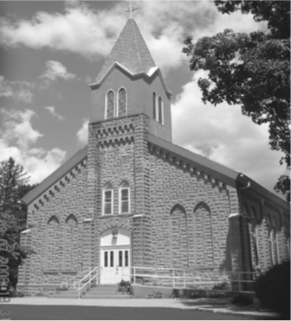
Saint Mary’s Village Church
P.O. Box 155
St. Mary-of-the-Woods, IN 47876
812-535-1261
jiannaccone!840@gmail.com
June 13, 2021
Eleventh Sunday in Ordinary Time

Our Mission: St. Mary’s Village Church is a Roman Catholic Community united through our common bonds of worship, faith formation, community building, outreach to others and responsible stewardship of resources. Together, we work to build up the Body of Christ by giving witness to the gospel message of Jesus.

Parish Life Coordinator Sr. Jane Iannaccone, SP 781-622-0440
Sacramental Minister Fr. Darvin Winters
Coordinator of Religious Education Jamie Richey

Sacramental Life
Weekend Worship Sunday 9:00 a.m. Reconciliation 1st Sunday – 8:30 a.m.

The sacraments of Baptism and Matrimony are arranged by calling the Parish Office to schedule preparation.

We welcome new members. To enroll call the Parish Office.

Today’s Readings: Ezekiel 17:22-24, 2 Corinthians 5:6-10, Mark 4:26-34
Responsorial Psalm: Lord it is good to give thanks to you.

Lectors: 6/13 Steve Norris, 6/20 Dave Hudgens 6/27 Eddie Breneman

Mass Intentions
For: By:
June 13 Hazel McKinney Jim & Flo Callahan
June 20 Taylor Corbett Head Jamie & Keith Richey

if you wish to have a mass said, the suggested stipend is $10.00. We are now scheduling masses for the second half of 2021

Please pray for:
Louise Arnold, Bill Marrs, Dick Stultz, Ronald Heyen, Janice Arnold, Jeannette Wrin, John Kirkham, Laura Stane, John & Joanne Kahl, Jonnie Hooper, Jane Frazier

Finance Report
May 30, 2021 | Budgeted | Actual |  | Additional Donations
Sunday Collection | $2096 | $2925 |  | Donuts | $100
Galvin Fund Donations | $96 | $175
Cemetery | $334 | $420

Birthday Blessings 6/13 Scott Thralls
Anniversary Blessings: 6/14 Katie & Kevin Miller,6/15 Toni & Bill Payne,6/17 Kristen & Kenneth Schlburg, Miriam & Greg Vermillion 6/20 Analiza & Lee Brockmeier, Patricia & Robert Kane,

Looking for activities for the kids this summer? Join us for Summer with the Saints, we will be meeting out-doors on Wednesday June 16th from 3:30-4:00 to hear a saint story and do a fun craft. All ages are welcome. Contact Jamie with any questions 812-208-6157

Mark your calendars Vacation Bible School will be held July 19th-23rd 6:00-8:30pm. If you would like to volunteer to help there are sign-up sheets at the back of the church.

If you know anyone who would be interested in learning more about the Catholic faith and becoming a member of the Catholic church, please have them contact Sister Jane

Archbishop Thompson and the other bishops of the State of Indiana are lifting the general dispensation from the obligation to attend Mass in person on Sundays and Holy Days effective this Sunday, June 11th the Solemnity of the Most Sacred Heart of Jesus

WALK, WADDLE OR RUN: The Quick Quack 5k/15k will take place on Saturday June 19th at Hawthorn Park the Children’s Walk begins at 7:40am. The 5k & 15k begins at 8:00am. Learn more and register on facebook@ QUICKQUACK5k. All proceeds benefit Catholic Charities.

Michael Kelly says ”Books change our lives…what we read today walks and talks with us tomorrow.” There are a variety of books & materials to borrow from the Deanery Center 1801 Poplar Street-812-232-8400

